**Task 01**

There is IT company who started their startup few months ago, currently this organization consist on two departments, 1) Software Department and 2) Development Department. Initially this organization hired 6 six employs each employee has unique ID (ex: 11) Three employees assign to each department on the basis of their skills. Write a c program that will take input from a user as ID. And display the assigned department. Using switch statement

**Task 02**

If the ages of Ali, Moazam and Fahd are input through the keyboard, write a program to determine the youngest of the three.

**Task 03**

Write a program to see greeting according to time using 24 hour format if time between is 5 to 11 it should greet “Good Morning”, if time is between 12 to 18 it should greet “Good Evening”, if time between 18 to 24 it should greet “Good Night”.

**Task 04**

Write a C program to input a character from user and check whether given character is small alphabet, capital alphabet, digit or special character, using if else.

**Task 05**

Write a c program that will take an input from user to select what type of conversion they want either Celsius to Fahrenheit or Fahrenheit to Celsius. After selection user will enter the integer figure of temperature for the conversion. Sample output attached.(Use Switch)

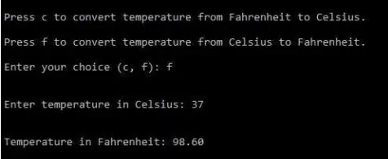

**Task 06**

Create a simple calculator using switch statement. Sample output is attached

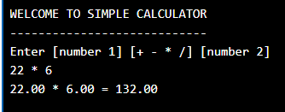

**TASK 07**

You must have seen the question before deleting anything like “Are you sure to delete [Y/y] / [N/n] ? Create a program that asks for this question if user enters Y or y it prints “Deleted successfully” if the user enters N or n it prints “Delete cancelled” otherwise it prints choose the right option

**TASK 08. Write a program to print day name using week day number.**

